**Day 3 : Statistical analysis using R**

**Session 9: Regression**

* 1. **Fitting regression models with lm()**

Symbols commonly used in R formulas

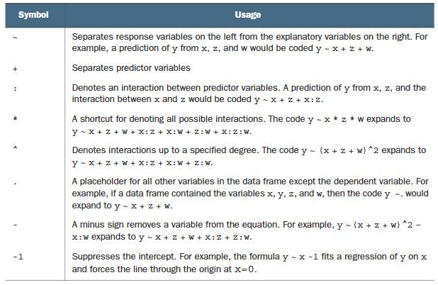

|  |
| --- |
| E034-simple_regression.R |
| # Set seed for reproducibility  set.seed(12345)  # Generate 1000 observations  n <- 1000  # Generate study_hours as uniform random numbers between 0 and 10  study_hours <- round(runif(n, min = 0, max = 10))  # Generate score as a linear function of study_hours with noise  score <- 50 + 5 * study_hours + rnorm(n, mean = 0, sd = 5)  # Combine into a data frame  df <- data.frame(study_hours, score)  # Perform linear regression  model <- lm(score ~ study_hours, data = df)  # Summarize the regression results  summary(model)  A screenshot of a computer code  Description automatically generated  # visualizing simple regression  library(ggplot2)  ggplot(data = df, aes(x=study_hours, y=score)) +  geom_point() +  geom_smooth(method = 'lm') +  theme_bw() |

* 1. **Multiple regression**

|  |
| --- |
| E035-multiple_regression.R |
| # Set seed for reproducibility  set.seed(12345)  # Generate 200 observations  n <- 200  # Generate age variable (cycles from 18 to 69)  age <- (1:n %% 52) + 18  # Generate educ_year variable (cycles from 0 to 17)  educ_year <- (1:n %% 18)  # Generate income variable with a linear relationship to age and educ_year, plus noise  income <- 20000 + 800 * age + 3000 * educ_year + rnorm(n, mean = 0, sd = 2000)  # Combine into a data frame  df <- data.frame(age, educ_year, income)  # Regression with omitted variable  model_omitted <- lm(income ~ age, data = df)  summary(model_omitted)    # Residual diagnostics for omitted variable model  plot(model_omitted, which = 1) # Residual vs Fitted plot    resid_omitted <- residuals(model_omitted)  hist(resid_omitted)    shapiro.test(resid_omitted) # Shapiro-Wilk test for normality [H0: normally distributed]    #---------------------------------------------------------------------------  # Multiple regression with correct specification  model_correct <- lm(income ~ age + educ_year, data = df)  summary(model_correct)    # Residual diagnostics for correctly specified model  plot(model_correct, which = 1) # Residual vs Fitted plot    resid_correct <- residuals(model_correct)  hist(resid_correct)    shapiro.test(resid_correct) # Shapiro-Wilk test for normality |

* 1. **Polynomial regression**

|  |
| --- |
| E036-polynomial_regression.R |
| library(ggplot2)  mtcars <- datasets::mtcars  #--------------------------------------  #simple regression  #--------------------------------------  fit <- lm(data = mtcars, formula = mpg ~ hp) # mpg: Miles/(US) gallon, hp: Gross horsepower  summary(fit) #R-squared : 0.6024, Residual standard error: 3.863    ggplot(mtcars, aes(x = hp, y = mpg)) +  geom_point() +  stat_smooth(method = 'lm', formula = y ~ x, color = 'red', se = FALSE) +  theme_bw()    #--------------------------------------  #Polynomial regression regression  #--------------------------------------  fit <- lm(data = mtcars, formula = mpg ~ hp + I(hp^2))  summary(fit) #R-squared : 0.7561, Residual standard error: 3.077    ggplot(mtcars, aes(x = hp, y = mpg)) +  geom_point() +  stat_smooth(method = 'lm', formula = y ~ x + I(x^2), color = 'red', se = FALSE) +  theme_bw() |

* 1. **Regression with interaction term**

|  |
| --- |
| E037-regression_with_interaction.R |
| mtcars <- datasets::mtcars  #generating a new interaction term hp * wt  mtcars$hp_wt <- mtcars$hp * mtcars$wt  fit <- lm(mpg ~ hp + wt + hp_wt, data=mtcars)  summary(fit)    #OR  fit <- lm(mpg ~ hp + wt + hp:wt, data=mtcars)  summary(fit)    #* -------------------------------------------------------------  #* A significant coefficient of interaction term indicates that  #* the relationship between mpg and hp varies by wt. Similarly,  #* the relationship between mpg and wt varies by hp.  #* -------------------------------------------------------------  # d(mpg)/d(hp) = - 0.12010 + 0.02785 * wt  wt = 1  print(- 0.12010 + 0.02785 * wt) #-0.09225  wt = 2  print(- 0.12010 + 0.02785 * wt) #-0.0644  wt = 3  print(- 0.12010 + 0.02785 * wt) #-0.03655  # d(mpg)/d(wt) = - 8.21662 + 0.02785 * hp  hp = 100  print(- 8.21662 + 0.02785 * hp) #-5.43162  hp = 150  print(- 8.21662 + 0.02785 * hp) #-4.03912  hp = 200  print(- 8.21662 + 0.02785 * hp) #-2.64662 |

* 1. **Logarithmic regression**

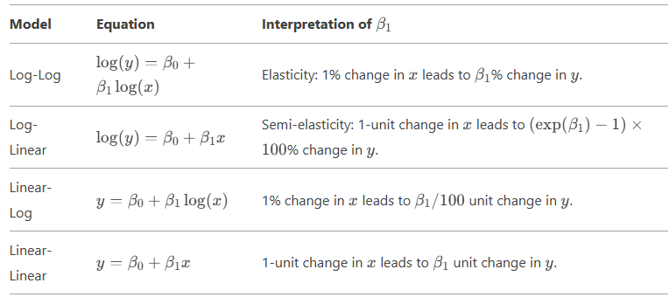

|  |
| --- |
| E038-logarithmic_regression.R |
| #----------------------------------------------------------  # Log-Log Regression  #----------------------------------------------------------  # Load data  mtcars <- datasets::mtcars  # Log-log regression  model_loglog <- lm(log(mpg) ~ log(disp), data = mtcars)  summary(model_loglog)    # A 1% increase in Displacement (cu.in.) reduces Miles/(US) gallon by ~0.46%.  #----------------------------------------------------------  # Log-Linear Regression  #----------------------------------------------------------  # Log-linear regression  model_loglin <- lm(log(mpg) ~ hp, data = mtcars)  summary(model_loglin)    # A 1-unit increase in horsepower reduces MPG by ~0.34% (exp(-0.0034287) - 1 ≈ -0.003422829).  #----------------------------------------------------------  # Linear-Log Regression  #----------------------------------------------------------  # Load data  trees <- datasets::trees  # Linear-log regression  model_linlog <- lm(Volume ~ log(Girth), data = trees)  summary(model_linlog)    # A 1% increase in girth increases volume by ~ 0.66 units (66.141 / 100). |

**Session 10: Logistic regression**

* 1. **Logistic regression**

Logistic regression is useful when you’re predicting a binary outcome from a set of

continuous and/or categorical predictor variables.

|  |
| --- |
| E039-logistic_regression.R |
| # Load necessary libraries  library(haven) # For reading SPSS files  library(dplyr) # For data manipulation  library(margins) # For calculating marginal effects  # Import SPSS file from the URL  data <- read_spss('data/010-hh.sav')  # Dropping missing values in HHSEX  data <- data %>% filter(!is.na(HHSEX))  # Creating new variables  data <- data %>%  mutate(  hh_size = HH48, # HH member size variable  urb_rur = factor(HH6), # 1=Urban 2=Rural  province = factor(HH7), # Province number  hhsex = factor(HHSEX) # 1=Male 2=Female  )  #setting 1=Urban as reference/base  data$urb_rur <- relevel(data$urb_rur, ref = '1')  #setting 2=Female as reference/base  data$hhsex <- relevel(data$hhsex, ref = '2')  #setting province 3 as base category/reference level  data$province <- relevel(data$province, ref = '3')  #-----------------------------------------------  # Running logistic regression  #-----------------------------------------------  logit_model <- glm(hhsex ~ hh_size + urb_rur + province,  data = data, family = binomial(link = "logit"))  summary(logit_model)    # Calculating marginal effects for logistic regression  logit_margins <- margins(logit_model)  summary(logit_margins)    #-----------------------------------------------  # Running probit regression  #-----------------------------------------------  probit_model <- glm(hhsex ~ hh_size + urb_rur + province,  data = data, family = binomial(link = "probit"))  summary(probit_model)    # Calculating marginal effects for probit regression  probit_margins <- margins(probit_model)  summary(probit_margins) |

**Task 8:**

Using NMICS6 data (011-Affairs.RData), complete the following tasks.

1. Load the **011-Affairs.RData**
2. Tabulate the frequency of **affairs** variable from **Affairs** dataframe.
3. Create a variable **ynaffairs** in **Affairs** dataframe such that the variable takes value 0 if no affairs and 1 if the person is involved in affairs.
4. Set **ynaffairs** and **rating** variables as factor variables.
5. Set ‘0’ as reference for **ynaffairs** variable, ‘5’ for **rating**, ‘no’ for **children**, and ‘female’ for **gender** variables.
6. Fit a logistic regression model with **ynaffairs** as dependent variable and **gender, age, yearsmarried, children, rating** as independent variable.
7. Calculate average marginal effect for each variables using the margins() function.

**library(dplyr)**

**library(margins)**

**load('data/011-Affairs.RData')**

**table(Affairs$affairs)**



**Affairs <- Affairs %>% mutate(ynaffair = case_when(affairs > 0 ~ 1, TRUE ~ 0),**

**ynaffair = factor(ynaffair),**

**rating = factor(rating))**

**table(Affairs$ynaffair)**



**#setting 0 : No-Affairs as base/reference**

**Affairs$ynaffair <- relevel(Affairs$ynaffair, ref = '0')**

**#setting 5 : Very happy as base/reference**

**# 1 = very unhappy, 2 = somewhat unhappy, 3 = average, 4 = happier than average, 5 = very happy.**

**Affairs$rating <- relevel(Affairs$rating, ref = '5')**

**#setting no children as base/reference**

**Affairs$children <- relevel(Affairs$children, ref = 'no')**

**#setting female as base/reference**

**Affairs$gender <- relevel(Affairs$gender, ref = 'female')**

**fit <- glm(ynaffair ~ gender**

**+ age**

**+ yearsmarried**

**+ children**

**+ rating,**

**data=Affairs,**

**family = binomial(link = "logit"))**

**summary(fit)**

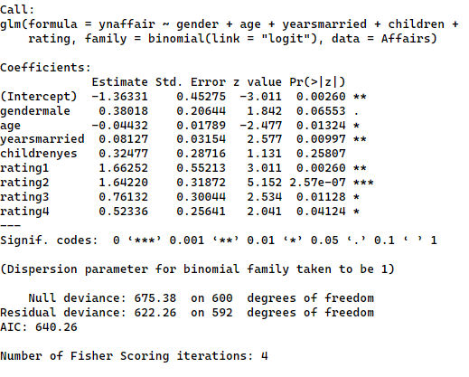

**summary(margins(fit))**

**Session 11: Time-series analysis**

* 1. **Stationarity concept**
* Stationarity refers to a time series whose statistical properties, such as mean, variance, and autocorrelation, remain constant over time.
* Non-stationary series are prone to spurious relationships.
  1. **Spurious relationships**

|  |
| --- |
| E040-spurious_regression.R |
| library(haven)  library(dplyr)  library(tseries)  library(ggplot2)  df <- read_dta('data/012-pwt1001.dta')  #keeping real GDP of Nepal from 1960 onwards  npl <- df %>%  filter(countrycode == 'NPL' & year >= 1960) %>%  select(year, rgdpe) %>%  rename(rgdpe_npl = rgdpe)  #keeping real GDP of USA from 1960 onwards  usa <- df %>%  filter(countrycode == 'USA' & year >= 1960) %>%  select(year, rgdpe) %>%  rename(rgdpe_usa = rgdpe)  #joining Nepal and USA data into one dataframe  df_npl_usa <- full_join(npl, usa, by = 'year')  #Visual inspection of stationarity  ggplot() +  geom_line(data = df_npl_usa, aes(x=year, y=rgdpe_npl), size = 1) +  labs(title = 'Nepal GDP') +  theme_bw()    ggplot() +  geom_line(data = df_npl_usa, aes(x=year, y=rgdpe_usa), size = 1) +  labs(title = 'USA GDP') +  theme_bw()    #Hypothesis testing of stationarity  adf.test(df_npl_usa$rgdpe_npl)    adf.test(df_npl_usa$rgdpe_usa)    #Running a regression (Spurious regression observed)  fit <- lm(formula = rgdpe_usa ~ rgdpe_npl ,data = df_npl_usa)  summary(fit)    #-------------------------------------------------------------  # Making series stationary and repeating the above steps  #-------------------------------------------------------------  df_npl_usa <- df_npl_usa %>%  mutate(dlrgdpe_npl = c(NA,diff(log(rgdpe_npl))),  dlrgdpe_usa = c(NA,diff(log(rgdpe_usa)))) %>%  na.omit()  #Visual inspection of stationarity  ggplot() +  geom_line(data = df_npl_usa, aes(x=year, y=dlrgdpe_npl), size = 1) +  labs(title = 'Nepal GDP growth') +  theme_bw()    ggplot() +  geom_line(data = df_npl_usa, aes(x=year, y=dlrgdpe_usa), size = 1) +  labs(title = 'USA GDP growth') +  theme_bw()    #Hypothesis testing of stationarity  adf.test(df_npl_usa$dlrgdpe_npl)    adf.test(df_npl_usa$dlrgdpe_usa)    #Running a regression (no spurious regression observed)  fit <- lm(formula = dlrgdpe_usa ~ dlrgdpe_npl ,data = df_npl_usa)  summary(fit) |

* 1. **True relationships**

|  |
| --- |
| E041-actual_relationship.R |
| library(haven)  library(dplyr)  library(tseries)  library(ggplot2)  df <- read_dta('data/012-pwt1001.dta')  df <- filter(df, countrycode == 'NPL' & year >= 1960) %>% select(year, rgdpe, ccon)  #Visual inspection of stationarity  ggplot() +  geom_line(data = df, aes(x=year, y=rgdpe), size = 1) +  labs(title = 'Nepal GDP') +  theme_bw()    ggplot() +  geom_line(data = df, aes(x=year, y=ccon), size = 1) +  labs(title = 'Nepal Consumption (Private + Govt)') +  theme_bw()    #Hypothesis testing of stationarity  adf.test(df$rgdpe)    adf.test(df$ccon)    #Running a regression  fit <- lm(formula = rgdpe ~ ccon ,data = df)  summary(fit)    #-------------------------------------------------------------  # Making series stationary and repeating the above steps  #-------------------------------------------------------------  df <- df %>%  mutate(dlrgdpe = c(NA,diff(log(rgdpe))),  dlccon = c(NA,diff(log(ccon)))) %>%  na.omit()  #Visual inspection of stationarity  ggplot() +  geom_line(data = df, aes(x=year, y=dlrgdpe), size = 1) +  labs(title = 'Nepal GDP growth') +  theme_bw()    ggplot() +  geom_line(data = df, aes(x=year, y=dlccon), size = 1) +  labs(title = 'Nepal Consumption (Private + Govt) growth') +  theme_bw()    #Hypothesis testing of stationarity  adf.test(df_npl_usa$dlrgdpe_npl)    adf.test(df_npl_usa$dlrgdpe_usa)    #Running a regression  fit <- lm(formula = dlrgdpe ~ dlccon ,data = df)  summary(fit) |

**Session 12: Stargazer for reporting regression results and the project work**

* 1. **stargazer**

|  |
| --- |
| E042-stargazer.R |
| mtcars <- datasets::mtcars  model1 <- lm(mpg ~ hp, data = mtcars)  model2 <- lm(mpg ~ hp + drat, data = mtcars)  model3 <- lm(mpg ~ hp + drat + cyl + wt, data = mtcars)  model4 <- lm(hp ~ disp + carb, data = mtcars)  library(stargazer)  #descriptive statistics table  stargazer(mtcars, type = 'text')    #displaying regression models results in a single table  stargazer(model1, model2, model3, model4, type = "text")    #defining the covariate and variable labels  stargazer(model1, model2, model3, model4, type = "text",  digits = 2,  covariate.labels = c('Gross horsepower (hp)',  'Rear axle ratio (dart)',  'Number of cylinders (cyl)',  'Weight (1000 lbs) (wt)',  'Displacement (cu.in.) (disp)',  'Number of carburetors (carb)'),  dep.var.labels = c("Miles/(US) gallon (mpg)", "Gross horsepower (hp)"),  notes = "Standard errors are in parentheses.")  #export and save the result as html  stargazer(model1, model2, model3, model4, type = "html", out = 'model_results.html',  digits = 2,  covariate.labels = c('Gross horsepower (hp)',  'Rear axle ratio (dart)',  'Number of cylinders (cyl)',  'Weight (1000 lbs) (wt)',  'Displacement (cu.in.) (disp)',  'Number of carburetors (carb)'),  dep.var.labels = c("Miles/(US) gallon (mpg)", "Gross horsepower (hp)"),  notes = "Standard errors are in parentheses.") |